Adoption and Special Guardianship Leadership Board

Headline Measures: Q3 2021/22

April 2022

Note: The Department for Education’s annual figures on adoptions and timeliness for children who have been adopted are published in the Children looked after in England including adoption SFR. This is the most robust source of information on adoption.

CHILDREN
The number of children moving into and through the adoption process continues to decline due to the decrease in the number of best interest decisions being made. The children who already have a best interest decision are waiting longer for permanence.
In Q3 2021/22 (31 December 2021) there were:
- 750 Agency Decision Maker decisions, a decrease of 7% (60n) from Q2 2021/22 and a decrease of 22% (210n) when compared to Q3 2020/21
- 660 Placement Orders granted, the same as Q2 2021/22 and a decrease of 20% (160n) when compared to Q3 2020/21
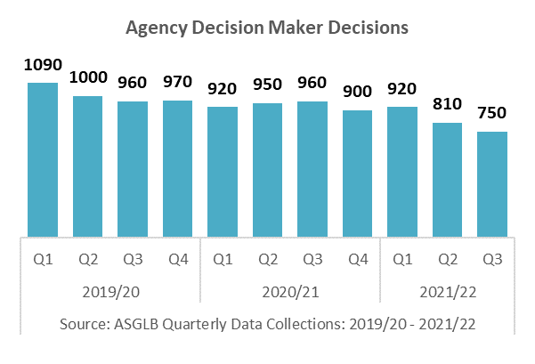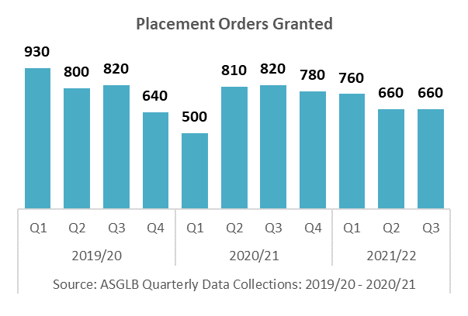
- 200 ADM reversals, a decrease of 5% (10n) from Q2 2021/22 and a decrease of 20% (50n) when compared to Q3 2020/21
- 27% of reversals were due to ‘Court did not make a PO’, an increase of 3 percentage points when compared to Q2 2021/22 and an increase of 9 percentage points when compared to 2020/21
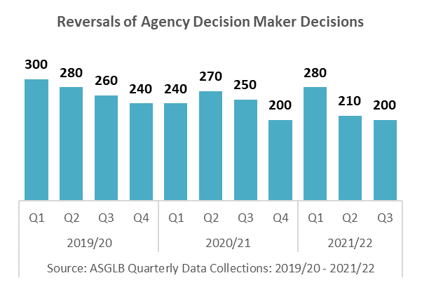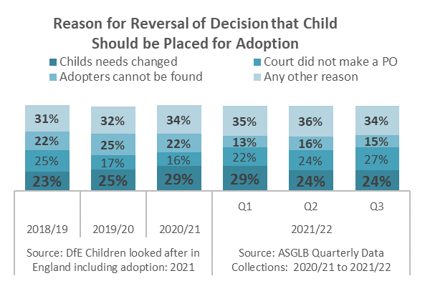
The number of Adoption Orders (AOs) granted continues to decline and there continues to be more Special Guardianship Orders (SGOs) granted than AOs.

In Q3 2021/22 there were:
- 660 Adoption Orders granted, a decrease of 15% (120n) from Q2 2021/22 and a decrease of 20% (160n) when compared to Q3 2020/21
- 970 Special Guardianship Orders granted, a decrease of 7% (70n) from Q2 2021/22 and a decrease of 10% (110n) when compared to Q3 2020/21
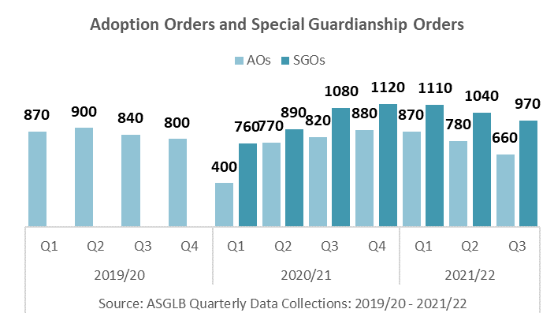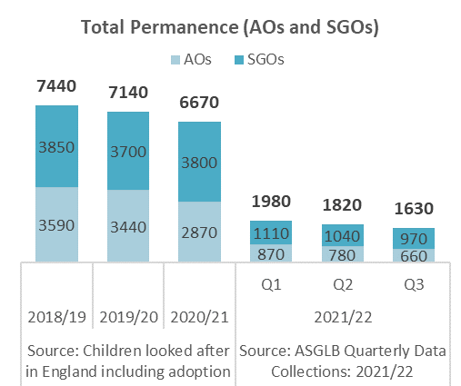
- 1630 total permanence orders granted (AOs & SGOs), a decrease of 10% (190n) from Q2 2021/22 and a decrease of 14% (270n) when compared to Q3 2020/21
- 120 children placed in an FFA/CP arrangement, a total of 320 for the first three quarters of 2021/22, 71% of the total for 2020/21

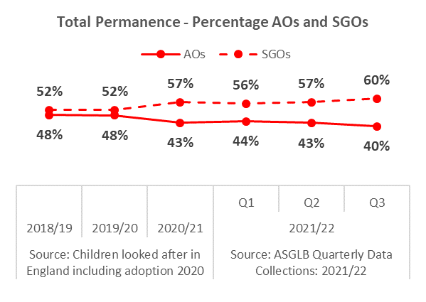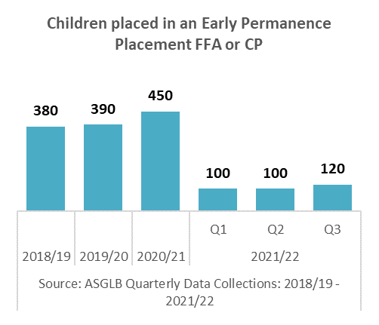
There has been an increase in the number of children waiting with a PO, and the proportion of children waiting with a PO 18+ months continues to increase.
In Q3 2021/22 there were:
- 1890 children with a PO waiting to be matched, an increase of 1% (10n) from Q2 2021/22 and a decrease of 9% (180n) when compared to Q3 2020/21
- 1000 children with a PO waiting to be matched 18+ months, an increase of 5% (50n) from Q2 2021/22 and an increase of 2% (20n) when compared to Q3 2020/21
- 53% of children with a PO have been waiting to be matched 18+ months, an increase of 1 percentage points from Q2 2021/22 and an increase of 6 percentage point when compared to Q3 2020/21
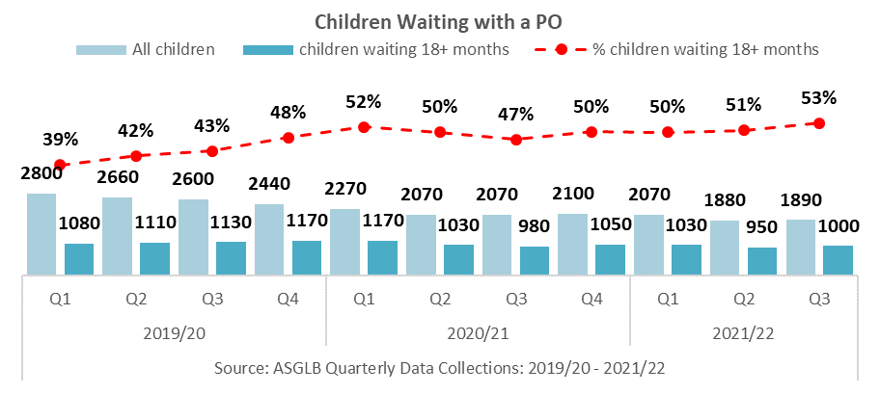
In Q3 2021/22 there were:
- 700 children matched with an adoptive family, a decrease of 5% (40n) from Q2 2021/22 and a decrease of 8% (60n) when compared to Q3 2020/21
- 610 children placed with an adoptive family, a decrease of 25% (200n) from Q2 2021/22 and a decrease of 19% (140n) when compared to Q3 2020/21
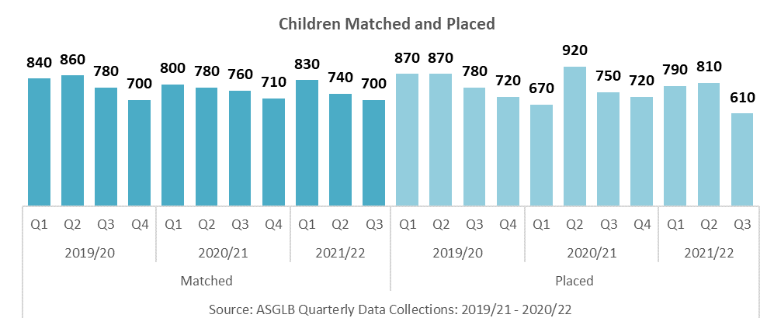
Timeliness for children has declined with children waiting longer for permanence.
In Q3 2021/22:
- The average number of days spent waiting to be placed with Placement Order since entering care was 681 days, an increase of 27 days from Q2 2021/22 and an increase of 43 days when compared to Q3 2020/21

- Scorecard Indicator A10 (average number of days between a child entering care and moving in with its adoptive family adjusted for foster care adoptions) was 455 days, an increase of 4 days from Q2 2021/22

- Scorecard Indicator A2 (average time between an LA receiving court authority to place a child and deciding on a match to an adoptive family) was 202 days, a decrease of 11 days from Q2 2021/22 and a decrease of 5 days when compared to Q3 2020/21
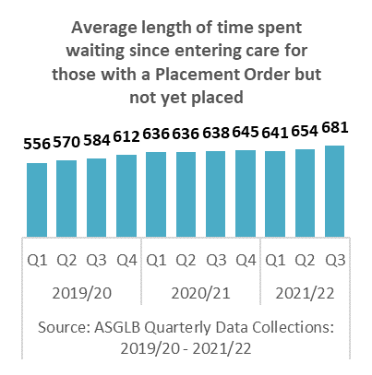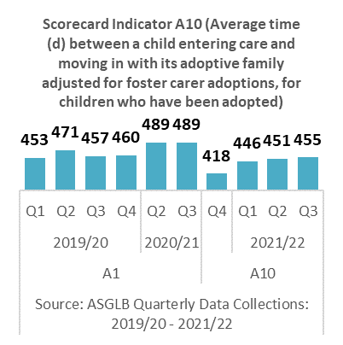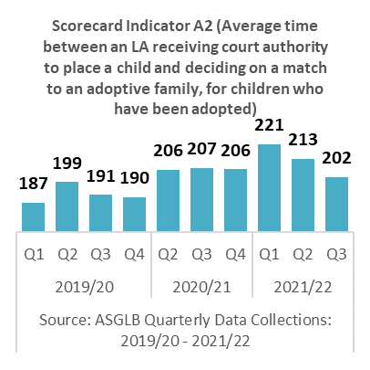
There has been an increase in the proportion of children with harder to place (HTP) characteristics waiting with a PO, and the proportion of children waiting with a PO 18+ months and the proportion of children with HTP characteristics adopted has remained the same.
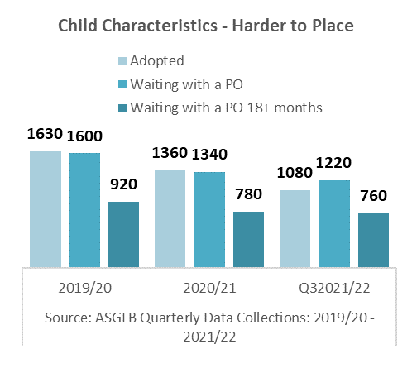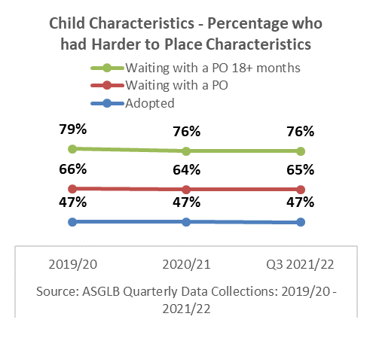
As at 31 December 2021/22 there were a total of:
- 1080 children with HTP characteristics adopted, 79% of the total number of children with HTP characteristics adopted in 2020/21
- 1220 children with HTP characteristics waiting with a PO, a decrease of 9% (120n) from 2020/21
- 760 children with HTP characteristics waiting with a PO 18+ months, a decrease of 3% (20n) from 2020/21
The decrease in the number of children waiting with a PO and waiting with a PO 18+ months is due the decline in the number of ADMS and POs as the number of children matched and placed also continues to decline.
The chart below gives a breakdown of the number of children adopted, waiting with a PO and waiting with a PO 18+ months by characteristics.

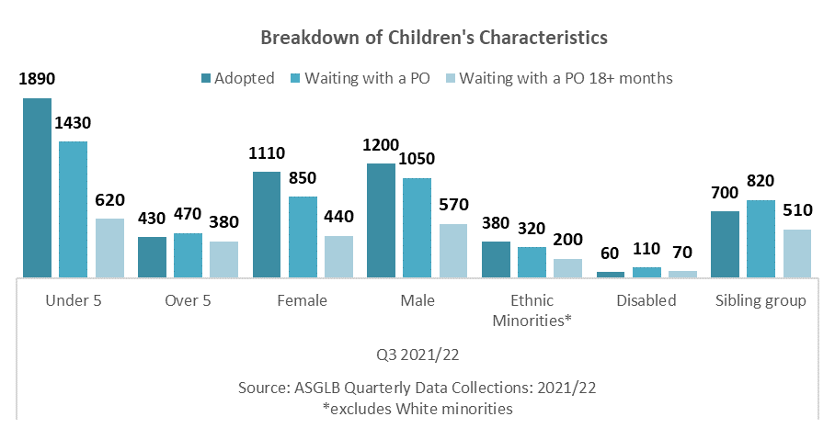
As at 31 December 2021/22:

- 82% (1890n) of children adopted were under 5, 52% (1200n) were male, 16% (380n) were from an Ethnic Minority (excludes White minorities) background, 3% (60n) had a disability and 30% (700n) were part of a sibling group

- 76% (1430n) of children waiting with a PO were under 5, 56%, (1050n) were male, 17% (320n) were from an Ethnic Minority (excludes White minorities) background, 6% (110n) had a disability and 37% (700n) were part of a sibling group

- 60% (620n) of children waiting with a PO 18+ months were under 5, 57% (570n) were male, 20% (200n) were from an Ethnic Minority (excludes White minorities) background, 7% (70n) had a disability and 51% (510n) were part of a sibling group
NB: "Harder to place" is defined as a child who is any of the following: 5 years or over, with an Ethnic Minority (excludes White minorities) background, disabled, or part of a sibling group. Children with more than one harder to place characteristic will be counted in each characteristic.

SPECIAL GUARDIANSHIP ORDERS
There continues to be a more children leaving care via a Special Guardianship Order than an adoption order.
In Q3 2021/22, there were:
- 970 SGOs granted, a decrease of 7% (70n) from Q2 2021/22 and a decrease of 10% (110n) when compared to Q3 2020/21
- 52% (500n) of the children were male, 48% (470n) were female
- 4% (40n) of the children had a disability, the same proportion when compared with 2020/21
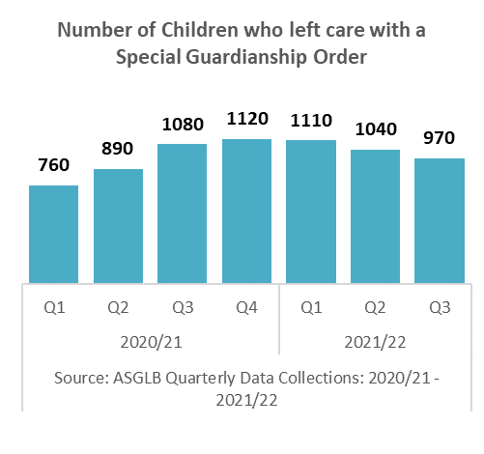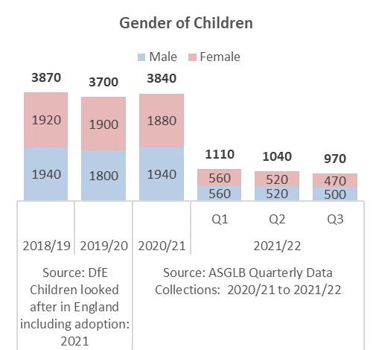
Children aged 1 to 4 continue to be the largest group of children who leave care with a Special Guardianship Order.
In Q3 2020/21:
- 37% (360n) of SGOs were granted for children aged 1 to 4, an increase of 2 percentage points from Q2 2021/22 and a decrease of 2 percentage points when compared to 2022/21
- 25% (240n) of SGOs were granted for children aged 5 to 9, a decrease of 3 percentage points from Q2 2021/22 and a decrease of 1 percentage point when compared to 2022/21
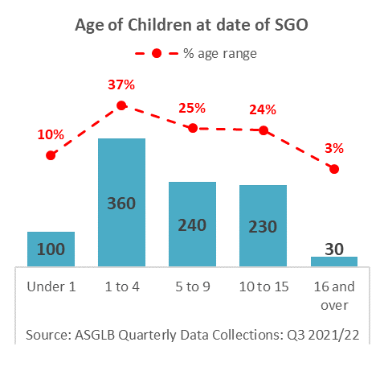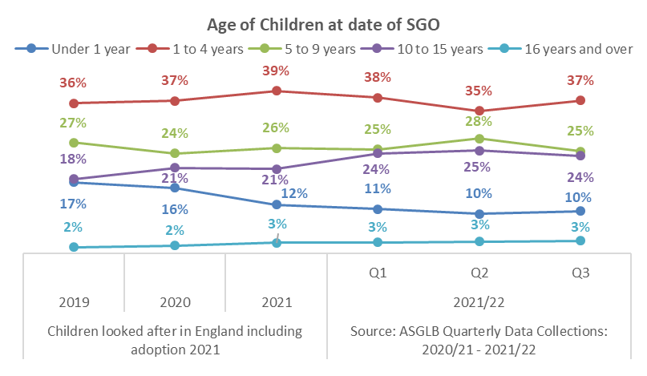
Children with a White ethnic background continues to be the largest ethnic group who leave care with a Special Guardianship Order
In Q3 2021/22:
- 80% (780n) of SGOs were granted for children with a White ethnic background, a decrease of 1 percentage point from Q2 2021/22 and a decrease of 3 percentage points when compared to 2020/21
- 20% (190n) of SGOs were granted for children with an Ethnic Minorities (excluding White minorities) background, an increase of 2 percentage points from Q2 2021/22 and an increase of 4 percentage points when compared to 2020/21
- 11% (110n) of SGOs were granted for children with a Mixed ethnic background, the largest represented of the Ethnic Minorities (excluding White minorities) groups
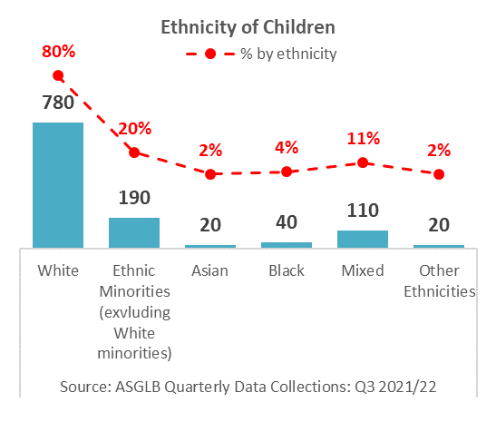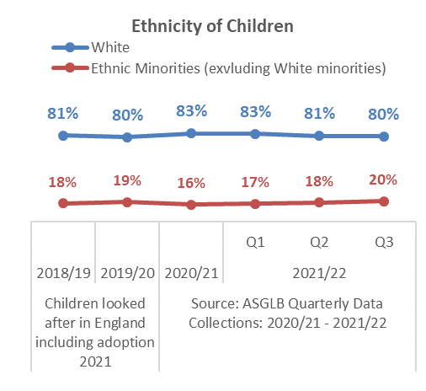
Children not in a sibling group continue to be the largest group of children who leave care with a Special Guardianship Order.

In Q3 2021/22:

- 57% (550n) of SGOs were granted to children not in a sibling group, an increase of decrease of 5 percentage points from Q2 2021/22 and an increase of 3 percentage points when compared to 2020/21
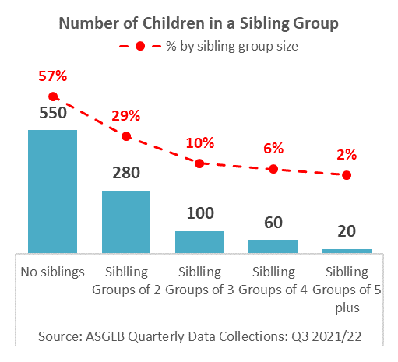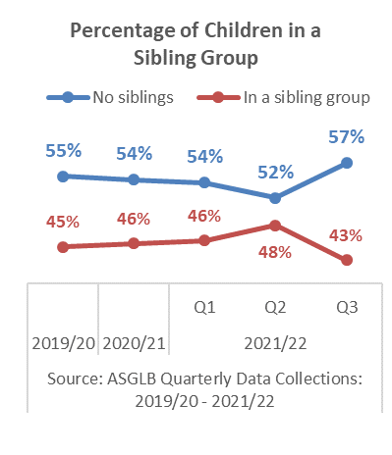
Grandparents were the largest represented group of Special Guardians.
In Q2 2021/22:
- 53% (510n) SGOs were granted to grandparents
- 36% (350n) Special guardians were aged between 50 to 59
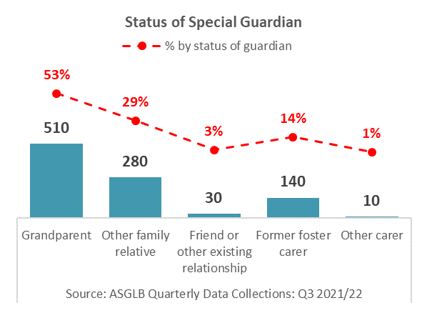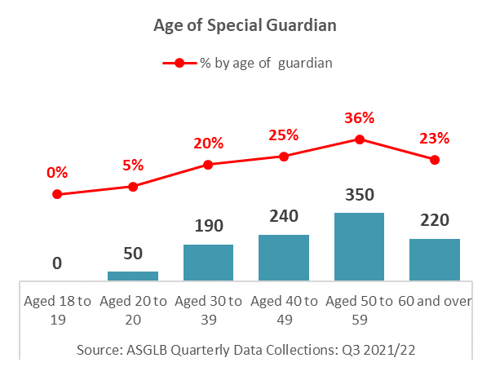
NB: 2020/21 was the first year that robust quarterly data was collected for SGOs.
Please not some figures may not add to the total due to rounding
ADOPTERS
The number of approved adopters waiting to be matched continues to increase and less adopter families are having a child matched and placed with them. Adopter registrations and approvals are beginning to decline which is impacting of the number of adopters not yet approved.
In Q3 2021/22 there were:
- 750 Registrations, a decrease of 19% (180n) from Q2 2021/22 and a decrease of 29% (310n) when compared to Q3 2020/21
- 750 Approvals, a decrease of 2% (20n) from Q2 2021/22 and a decrease of 16% (140n) when compared to Q3 2020/21
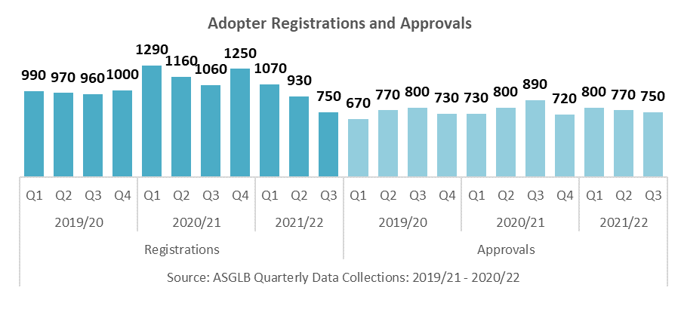
- 2670 Prospective adoptive families not yet approved, a decrease of 9% (250n) from Q2 2021/22 and a decrease of 10% (300n) when compared to Q3 2020/21
- 2470 Approved adoptive families waiting to be matched, an increase of 5% (110n) from Q2 2021/22 and an increase of 15% (330n) when compared to Q3 2020/21
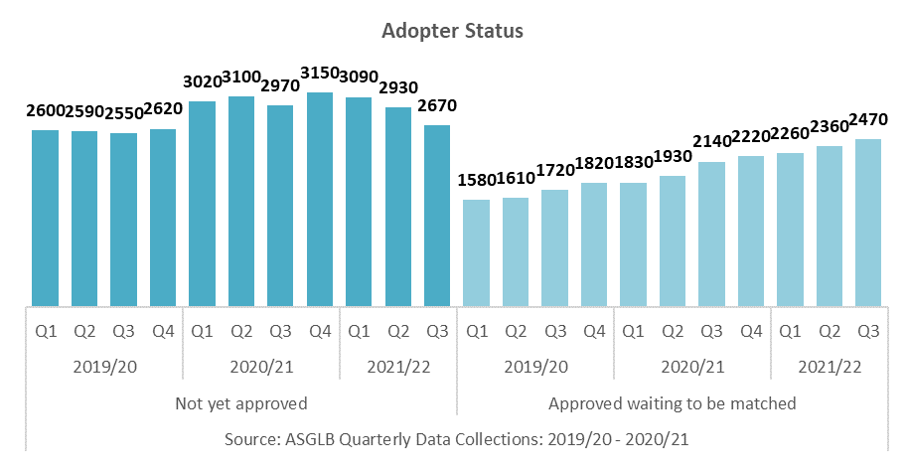
Overall the number of adopters being matched and having a child placed with them is in decline. The slight increase in adopters being matched with a child in Q2 will be reflected in the number of adopters having a child placed with them in Q3.
In Q3 2021/22 there were:
- 590 Adoptive families matched to children, a decrease of 5% (30n) from Q2 2021/22 and a decrease of 6% (40n) when compared to Q3 2020/21
- 520 Adoptive families with a child placed, a decrease of 21% (140n) from Q2 2020/21 and a decrease of 16% (100n) when compared to Q3 2020/21
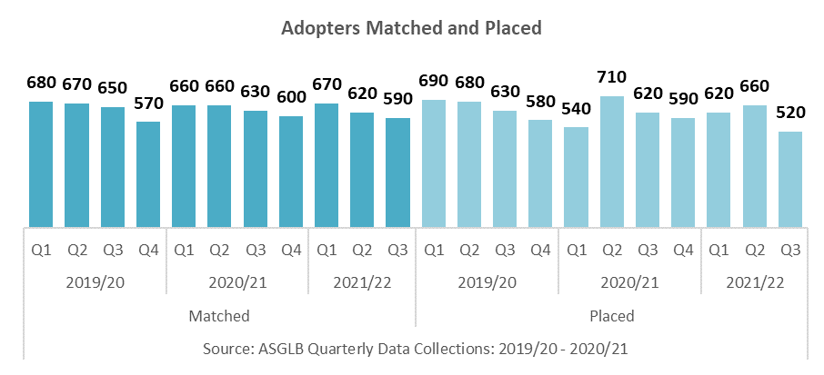
Timeliness for adoptive family has declined with it taking longer for adoptive families to be approved and matched.
In Q3 2021/22:
- 25% of adoptive families were approved within 6 months of registration, a decrease of 1 percentage point from Q2 2021/22 and a decrease of 3 percentage points when compared to Q3 2020/21
- 22% of approved adoptive families had a child matched with them within 3 months of approval, a decrease of 1 percentage point when compared to Q2 2021/22 and a decrease of 7 percentage points when compared to Q3 2020/21
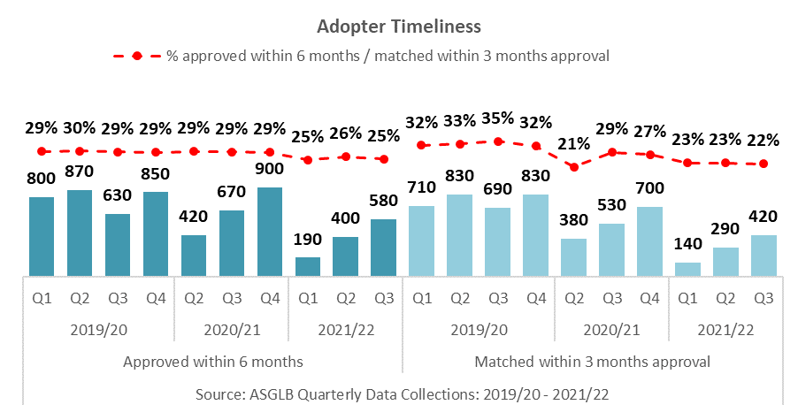
DATA SOURCES
ASGLB Quarterly Data Collection
In quarter 3 2021/22 the response rate from local authorities for the child level section was 100% and the adopter level sections was 100%. The response rate for the adopter level section from Voluntary Adoption Agencies was 100%. Therefore, national and regional figures on adoptions and adopters do not include estimates made for non-responses.

SSDA 903 Data Collection
Local authorities provide data on their looked after children using the SSDA903 collection. Data are collected from all local authorities. The information is collected at child level and includes information about the child’s characteristics and their dates for each stage of the care process, including adoption. The data goes through thorough quality assurance and local authorities are able to update their historic data annually. We therefore view this as the most robust source of information on adoption. It is used to produce the Children looked after in England including adoption (SFR) and the Adoption Scorecards. The most recent data covers the year ending 31 March 2021.

Ofsted Data
Ofsted have previously published annual data on the recruitment of adopters and the children placed with them. From quarter 4 2014-15 the Ofsted data collection became part of the quarterly survey.

ABOUT THIS PUBLICATION
This publication was produced by The Children and Social Care Secretariat, delivered by Coram-i on behalf of the Department for Education.

download: ASGLB Quarterly Data
email: asglb@coram.org.uk
visit: Adoption and Special Guardianship Leadership Board
write: Coram-i, Coram Campus, 41 Brunswick Square, London WC1N 1AZ

